Task 3: Login System with Validation

Aim
To develop a login system that validates user input using JavaScript, verifies credentials from a database, and displays dynamic error messages.

Algorithm
- Start
- Create a login form with username and password fields
- When the user clicks the login button:
  - Check if fields are empty
  - If empty → display error message
- Validate input format (e.g., minimum length)
- Compare entered credentials with stored database values
- If credentials match:
  - Display success message / redirect to dashboard
- Else:
  - Show error message (“Invalid Username or Password”)
- Stop

Program:

<!DOCTYPE html>
<html>
<head>
<title>Login System</title>
<style>
body {
font-family: Arial;
background-color: #f2f2f2;
}
.login-box {
width: 300px;
margin: 100px auto;
padding: 20px;
background: white;
border-radius: 10px;
box-shadow: 0px 0px 10px gray;
}
input {
width: 100%;
padding: 8px;
margin: 8px 0;
}
button {
width: 100%;
padding: 10px;
background: blue;
color: white;
border: none;
}
.error {
color: red;
}
.success {
color: green;
}
</style>
</head>
<body>

<div class="login-box">
<h2>Login</h2>
<input type="text" id="username" placeholder="Enter Username">
<input type="password" id="password" placeholder="Enter Password">
<button onclick="validateLogin()">Login</button>
<p id="message"></p>
</div>

<script>
function validateLogin() {
var username = document.getElementById("username").value;
var password = document.getElementById("password").value;
var message = document.getElementById("message");

// Dummy database
var dbUser = "admin";
var dbPass = "1234";

if (username === "" || password === "") {
message.innerHTML = "All fields are required!";
message.className = "error";
}
else if (username === dbUser && password === dbPass) {
message.innerHTML = "Login Successful!";
message.className = "success";
}
else {
message.innerHTML = "Invalid Username or Password";
message.className = "error";
}
}
</script>

</body>
</html>

Output:
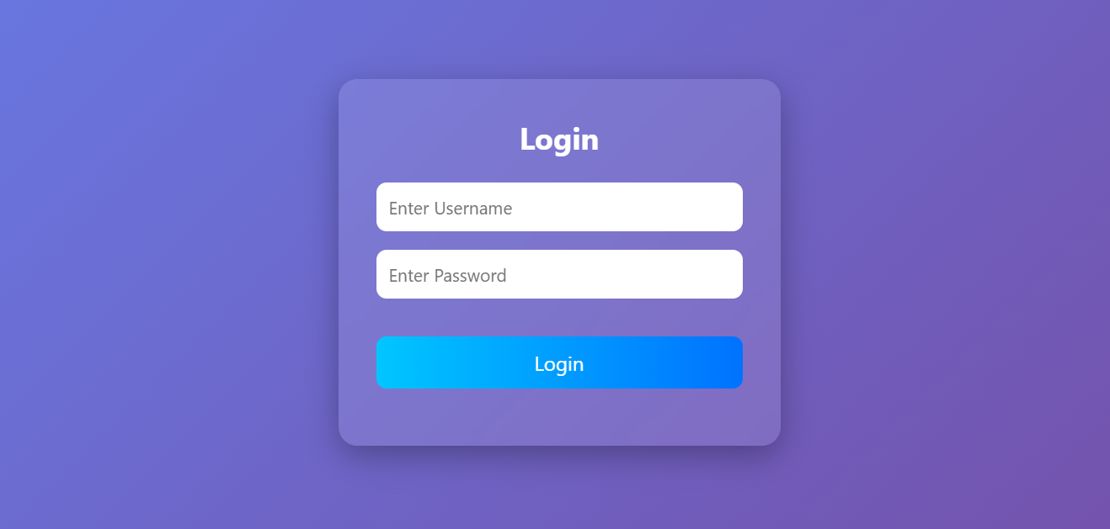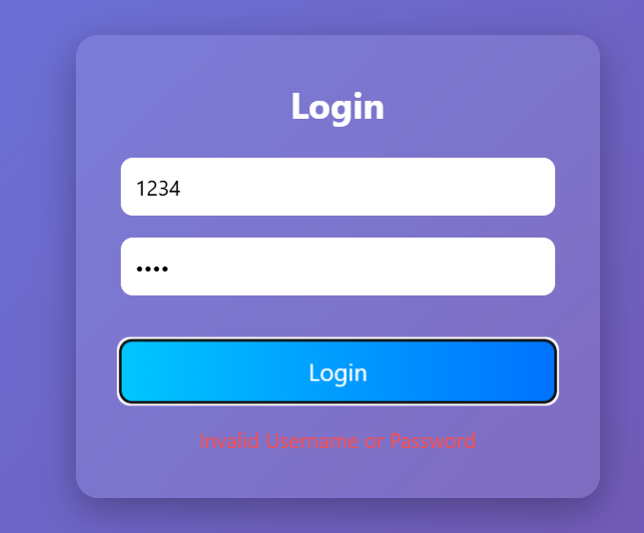
Result
The login system was successfully developed with input validation, credential checking, and dynamic error message display. This system demonstrates the basic functionality of authentication used in real-world web applications.

